***AURA CLASSIC DESIGN:***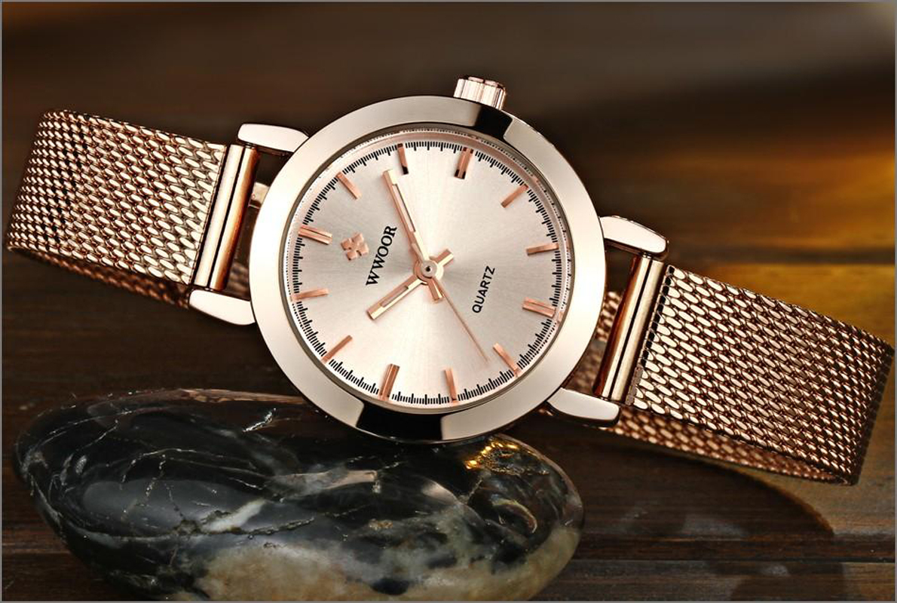

***DETAILS ABOUT THIS WATCH:***

Gender: Women  
Case Color: Rose Gold  
Case Size: 25 mm  
Case Thickness: 8 mmMovement Type: Two Hand  
Watch Strap Color: Rose Gold  
Strap Width: 12 mm  
Strap Material: Stainless Steel Mesh

***SPACES:***

**CASE SIZE:**25mm

**CASE SHAPE:**Round

**CASE MATERIAL:**Stainless Steel

**CASE THICKNESS:**11mm

***Price:***

***Rs:3,000***